Notes on Archery
You will need to know all parts of the anatomy of the bow and arrow.

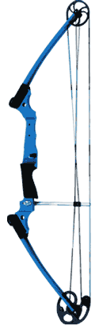

You will need to know the point value for each section of the target. You will be asked to total the point value of three positions on the target.
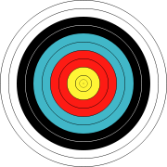

You will need to list the whistle commands without an answer key.
Two Blasts- Archers to the Shooting Line
One Blast- Begin Shooting
Three Blasts- Retrieve Your Arrows
Four Blasts- Stop Shooting

Safety Hints-
- Bows and arrows are weapons capable of inflicting serious harm- Handle with Care!
- Never point a nocked arrow away from the target-it is like a loaded gun.
- Obey commands.
- Never step over the shooting line.
- Avoid bulky clothing and dangling jewelry. Tie long hair back.
- Never run with an arrow in your hand.
- Never dry-fire the bow!
Shooting Position
- Straddle the shooting line.
- Bow arm is slightly bent so the force comes through the wrist, not the thumb.
- Index finger is under jawbone.
- String is touching center of nose and chin.
Most common errors resulting in faulty arrow flight:
- Peeking- looking up to watch arrow
- Relaxing- letting draw hand more forward
- Jerking- draw hand away from face
- Hunching-the shoulder of arm holding the bow
- Throwing bow arm toward target
- Dropping bow arm
Terminology
- Nocking an arrow- to place an arrow on bowstring in preparation for drawing
- Draw- to pull bowstring back to shoot.
- Addressing target- taking proper stance for shooting
- Release- relaxing fingers quickly and smoothly without any other movement of the body

